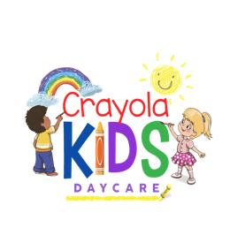 PARENT AGREEMENT

Hours of operation: Monday – Friday 6:00 am – 6:00 pm Date: ___________________
Drop-off __________________ Pick-up _________________
Child’s Name: ________________________________________ DOB: ___________________

Weekly Rate $250 (8 Hour Shift) 6 weeks to 5 years old
ç
Weekly Rate $290 (10 Hour Shift) 6 weeks to 5 years old
Part- Time $180 (3 Days a week) 6 weeks to 5 years old
Walk-In Daily Rate $65 (Must be registered) 6 weeks to 5 years old

- Holidays: CRAYOLA KIDS DAYCARE is CLOSED on the following days:
Martin L, King Day, President’s Day, Easter Good Friday, Memorial Day, Independence Day, Labor Day, Thanksgiving Day & After Christmas Eve & Day, New Year’s Day, (Please see page 5. In Handbook for remaining closure dates)
- Tuition: Tuition is due in advance on the 1st of every month. If tuition is not paid on the 1st of the month your child may not be permitted to attend. (Please see page 12 in Handbook)
- Children may not attend Crayola Kids Daycare while ill. Children who become ill while at Crayola Kids Daycare will need to be picked up based on severity of the situation as referenced in the health policy guidelines. Children should be out of school until symptoms and fever free for 24 hours. In an event that your child will be absent from school I ask that you notify me.
- Lateness: There will be a nominal charge of $5 every 10 minutes past your scheduled pickup time. Please call us for any unusual circumstances Crayola reserves the right to deny cancel or suspend a child’s enrollment at any time it’s sole discretion if we deem such action to be in the best interest of the child or Crayola. We request a minimum of two week notice departures.

Parent Signature: __________________________ Date: _____________________

_________________________________________ Date: _____________________
Crayola Kids Daycare
Mrs. Mosquea Rojas

